Lección 1: Examen – Parte 1
Parte 1 – Leer y Escribir (Reading and Writing)
- Two students meet on the first day of class. Fill in the blanks with a Spanish word. Not all terms will be used.
buenas
buenos
dónde
la vista
llama
llamo
luego
mañana
me
nada
Nos
qué
Soy
te
una

Diana – Hola, (1) _____________ tardes. ¿Cómo (2) _____________ llamas?
Toni – Hola, me (3) _____________ Toni, ¿y tú?
Diana – Diana. ¿De (4) _____________ eres?
Toni – (5) _____________ de México. ¿Y tú?
Diana – De los Estados Unidos. Oye, (6) ¿ _____________ hora es?
Toni – Es la (7) _____________ de la tarde.
Diana – Gracias.
Toni – De (8) _____________. (9) _____________ vemos en clase.
Diana – Sí. Hasta (10) _____________.

- Read these bulletin board notices and answer the questions with sentences. Write the numbers as words.

- ¿Quién es la chica?
- ¿Qué hay en el cuaderno?
- ¿De dónde es el chico?
- Escribe (Write) el número de teléfono del chico.
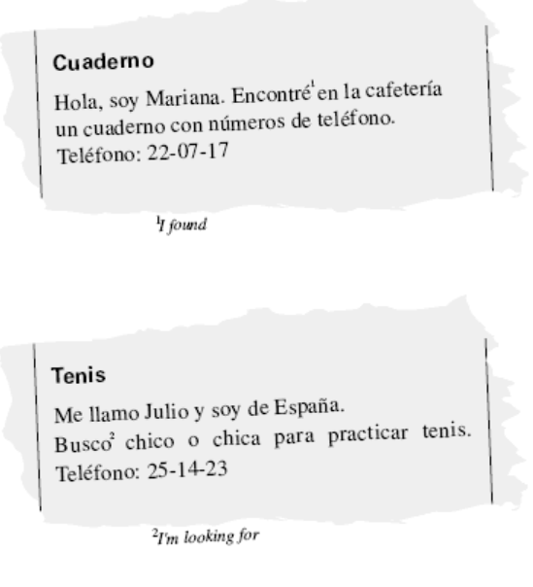

- Write a short paragraph. Include the following information:
  - Say hello and introduce yourself
  - Say where you are from
  - Tell me who one of your friends is
  - Tell me where he/she is from
  - Tell me you are both students using the pronoun nosotros/as and the verb ser
________________________________________________________________________________________________________________________________________________________________________________________________________________________________________________________________________

Crédito Extra: Answer the following questions in English. Write in complete sentences.
- What does Día de los Santos celebrate? When is it celebrated?
- What does Día de los Muertos celebrate? When is it celebrated?
- What is one thing from the video you found interesting? (You can’t mention anything from #1-2 above.)

