Cap. 2A - El 7 de diciembre
Caliente la mente – Put the following terms in order by labeling them A (first term) – J (last term).

novena
cuarta
segunda

quinta
primera
décima

séptima
tercera
sexta
octava

Escribir
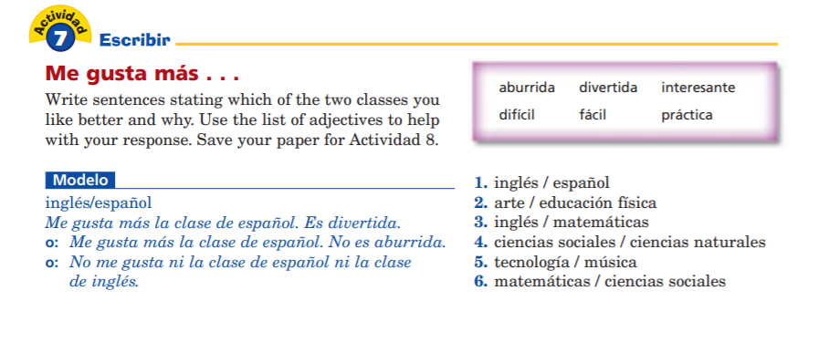
- _______________________________________________________________________
- _______________________________________________________________________
- _______________________________________________________________________
- _______________________________________________________________________
- _______________________________________________________________________
- _______________________________________________________________________
Comunicar – Alternate asking and answering (evens / odds). HOMIES: You will complete this in VHL.
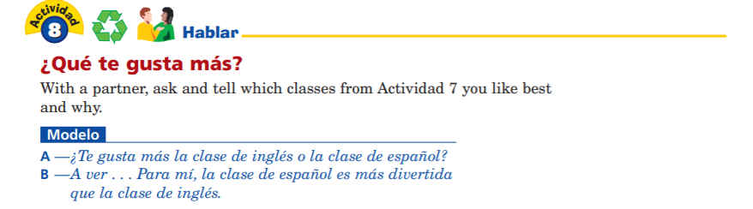
Gramática: Subject Pronouns
- Read over p. 2 in your packet to review the concept of subject pronouns in Spanish.
- Now complete the activities below.

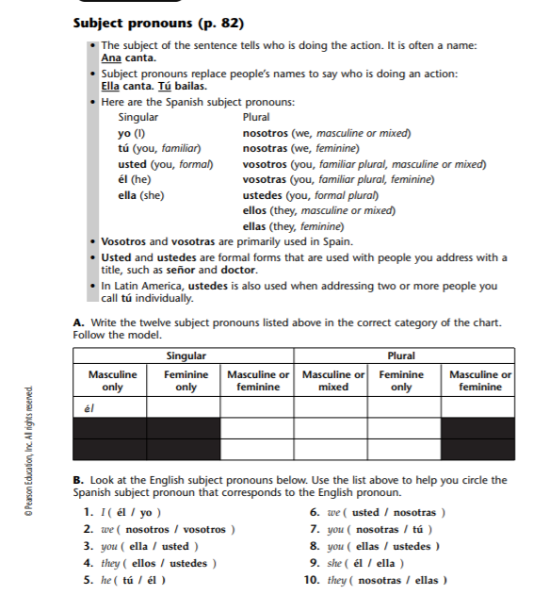
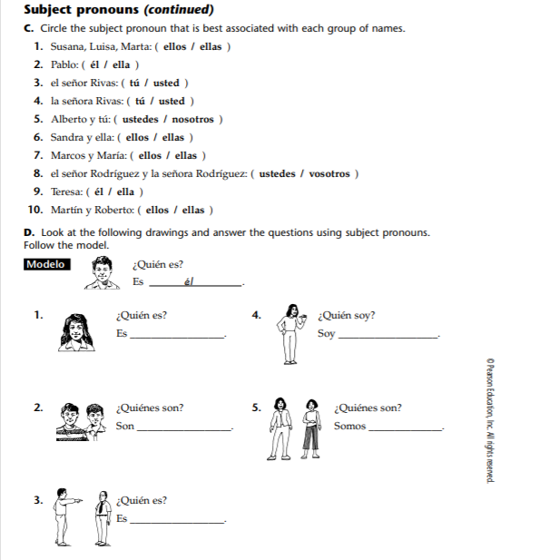

Tareas – Complete the following activities for HW tonight.
- Complete p. 7 in the packet. If you need more of a refresher on subject pronouns, watch the GramActiva video linked in the PPT uploaded to CTLS.
- Complete Audio Activity #5 (p. 12 in packet) – Audio sent to your school email.

