Muscular Endurance Dice Game

Directions:
- You will roll the set of dice a total of 6x on Monday, Tuesday, Wednesday, and Thursday of this week to determine your workout each day.
- One dice will correspond with the top row and one will correspond with the side column. Where the two numbers meet on the chart below, that is the activity you will perform.
- You will do 3 sets of the workout. (Go through all six exercises 3x.)
- Record what exercises you do on the blank log on page 2.
- If you do not have dice, use this video: https://www.youtube.com/watch?v=_VwOYXIsHqg

 | 1 | 2 | 3 | 4 | 5 | 6
1 | Side Plank - 20 sec. each side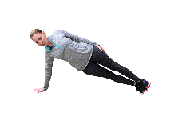 | 18 Calf Raises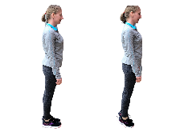 | Plank - Hold for 30 seconds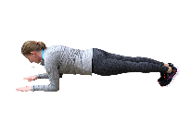 | 20 Jumping Jacks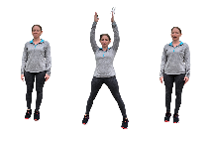 | 10 Push-ups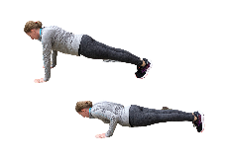 | 30 High Knees, running in place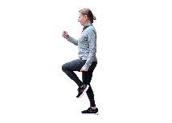
2 | 12 Dips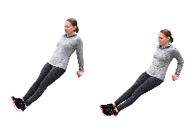 | 16 Vertical Leg Crunches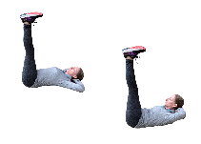 | 10 Push-ups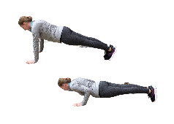 | 16 Trunk Twists with light weight (like a book) | 10 Side Leg Raises each side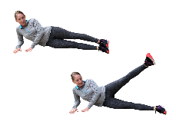 | 20 Plank Shoulder Touches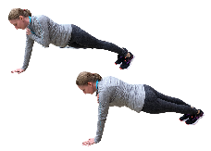
3 | 15 Jumping Jacks | 12 Squat Jumps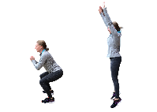 | 14 Bicycle Crunches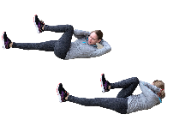 | 15 Squats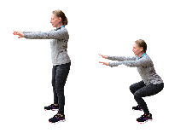 | 12 Dips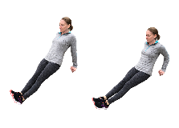 | 10 Calf Raises 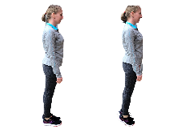
4 | 16 Trunk Twist with light weight | 10 Supermans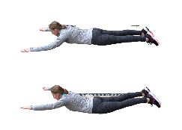 | 16 Lunges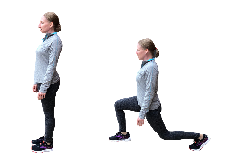 | V-Sit and hold for 20 seconds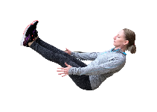 | 12 Squat Jumps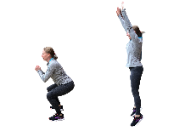 | 10 Burpees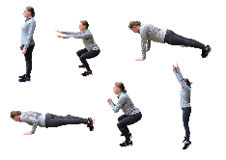
5 | 10 Burpees  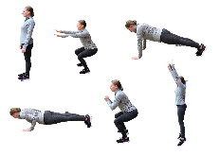 | 18 Squats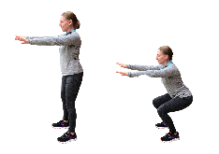 | 10 Side Leg Raises each side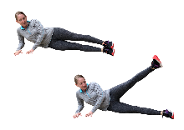 | 15 Calf Raises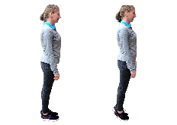 | 16 Curl-ups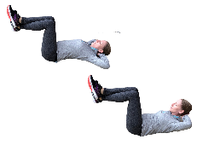 | 15 Jumping Jacks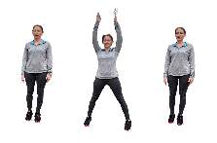
6 | 16 Lunges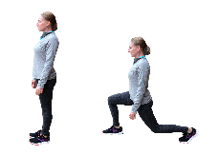 | 8 Push-ups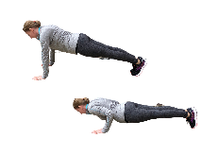 | 12 Dips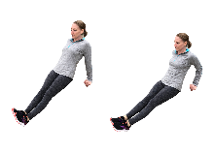 | 18 Plank Leg Lifts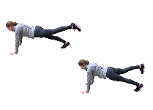 | 10 Supermans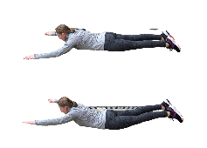 | 12 Sit-ups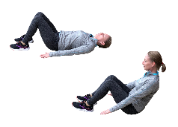
Workout Log
Things to Remember:
- Do each workout (Exercises #1-6) 3 times on the designated days.
- Check in with me during your assigned session – either Tuesday or Thursday.
- We will turn in the assignment on Friday during class.

 | Monday | Tuesday | Wednesday | Thursday
Exercise #1
Exercise #2
Exercise #3
Exercise #4
Exercise #5
Exercise #6

Answer the questions below. Visit: https://darebee.com/posters/what-muscles-do-and-how-to-train-them.html (scroll down the page below the pictures) for any bold terms you don’t know.
- Name two exercises from the chart that works the ABS.

- Name two exercises from the chart that works the BICEPS and TRICEPS.
- Name two exercises from the chart that works the GLUTES, HAMSTRINGS and QUADS.
- Name two exercises from the chart that improves CARDIORESPIRATORY ENDURANCE.
- Which workout this week was the most challenging (Monday, Tuesday, Wednesday, or Thursday)? How hard would you say your body worked on this day?
  - Light intensity – could carry on a conversation for hours
  - Moderate intensity – able to hold short conversations
  - Vigorous intensity – on the verge of being uncomfortable; short of breath; can speak a sentence
  - Maximum intensity – out of breath; hard to speak more than one word at a time

