Cap. 1B – el 19 de noviembre
Caliente la mente: Complete the following phrases about two classmates.
- ___________________________ es una chica _______________________ y _________________________.
- ___________________________ es un chico _______________________ y __________________________.

Práctica #1 - Escuchar: Listen how Nacho describes his ex-girlfriend. How many things do they have in common? Put an X on pictures that show ways in which they are very different and put a circle around the pictures that show ways they are similar.
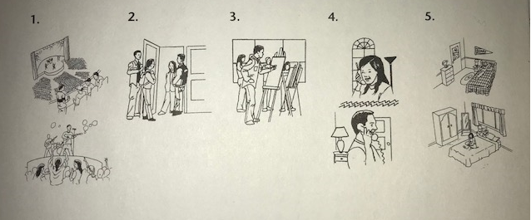
Práctica #2 – Escribir: Rewrite the scrambled words to create a sentence. Follow the pattern from before: subject + verb + [article + noun] + adjective.
- atrevida es una chica Marina _______________________________________________
- es un Tito perezoso chico _______________________________________________
- deportista chica una es Paquita _______________________________________________
- Marcos chico un es reservado no _______________________________________________
- chico no Rafael es estudioso un _______________________________________________
- no una Teresa chica es inteligente _______________________________________________
Práctica #3: Hablar: Get to know your partner better by asking the following questions. You don’t need to write anything down, but you DO need to react to your partner’s answers (see below.) Alternate who asks the odds and who asks the evens.
Reacciones:
(To agree)
- Yo también.
- No soy ______________ tampoco.
(To disagree)
- Yo soy _______________.
- No soy _______________.

- ¿Eres más artístico/a o deportista?
- ¿Eres más desordenado/a o ordenado/a?
- ¿Eres más serio/a o gracioso/a?
- ¿Eres más reservado/a o atrevido/a?
- ¿Eres más perezoso/a o trabajador/a?
- ¿Eres más inteligente o talentoso/a?
- ¿Eres más paciente o impaciente?
- ¿Eres más reservado/a o sociable?
Tarea: Choose sentence parts from each of the word banks below, then put them in the correct order to form complete sentences. The only box you can repeat terms in is the Verbs box.
Subjects:  Alec Yo  Sra. Mack Rolando  Sr. Jansen Tú | Verbs:  es soy eres
Articles + Nouns:  un estudiante una estudiante  un chico un profesor  una chica una profesora | Adjectives:  reservado/a deportista  inteligente estudioso/a  perezoso/a bueno/a

- __________________________________________________________________________________________
- ___________________________________________________________________________________________
- ___________________________________________________________________________________________
- ___________________________________________________________________________________________
- ___________________________________________________________________________________________
- ___________________________________________________________________________________________
- ___________________________________________________________________________________________
- ___________________________________________________________________________________________
- ___________________________________________________________________________________________
- ___________________________________________________________________________________________

