Cap. 1B – el 17 de noviembre
Caliente la mente
Based on the sentences below, tell me the gender of the person (M) or (F). If you can’t tell, write (?).
- Es trabajador.
- Según la familia, es inteligente.
- No es ni atrevida ni sociable.
- Es impaciente y deportista.
- Le gusta escuchar música y usar la computadora.

Práctica #1: Frida y Diego
Frida and Diego, who are opposites, are talking on the phone. Frida, the sociable one, is doing all the talking. Using the pictures of the friends below, write what Frida might be saying about herself and about Diego. Follow the models.
- __________________________________________________
- __________________________________________________
- __________________________________________________
- __________________________________________________
- __________________________________________________
- __________________________________________________
- __________________________________________________
- __________________________________________________
- __________________________________________________
- __________________________________________________
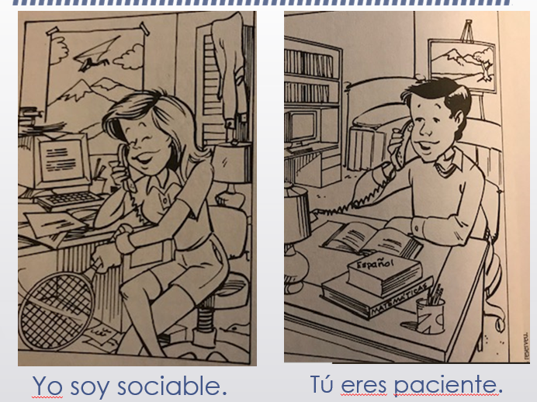

Práctica #2: ¿Cómo es Paloma?
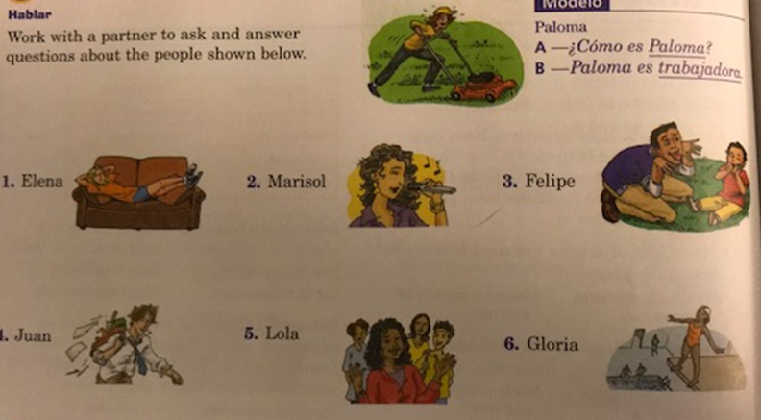

This oral. No need to write anything down.

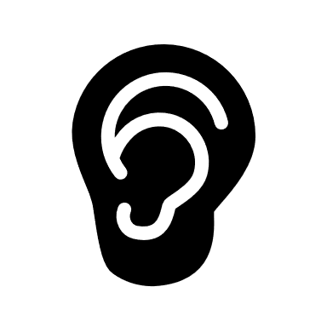 Práctica #3: Audio Act. 7
Listen to the conversations and decide whether they are talking about a boy, a girl, or if you can’t tell by what is being said. Place a check mark in the appropriate box of the table. You will hear each statement twice.

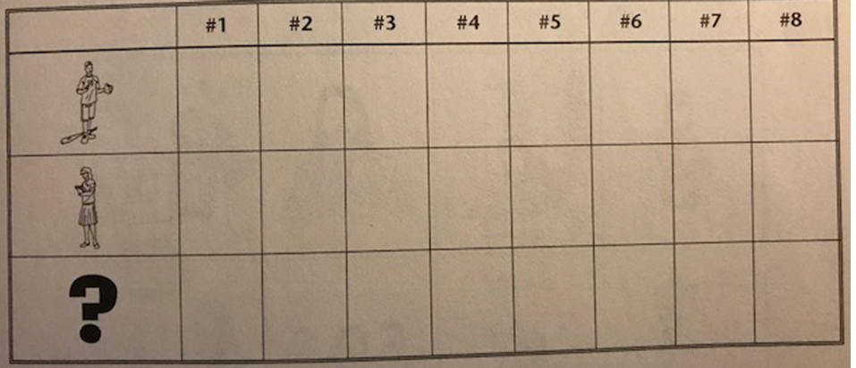
Práctica #4: El poema “Soy Elena”
The following poem is called a poema en diamante. Can you guess why? After you’ve read the poem, answer the questions.
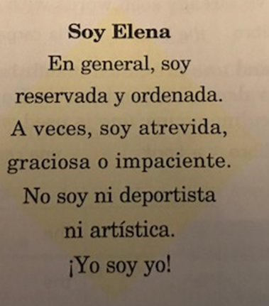
- Which activity would you invite Elena to do based on what she has told you about herself?
  - dibujar
  - escuchar música
  - correr

- Edit the poem as if a boy Tomás wrote it instead of Elena.

Tarea: Poema en diamante – Due Wednesday
Write un poema en diamante about yourself. Choose adjectives that describe you. Substitute your adjectives in the poem above. Be sure to write the poem in the form of a diamond. Add pictures/clipart/doodles to illustrate your adjectives. Color is great, but not a requirement.
- Upload to CTLS – a template is uploaded (or you can create your own)
- Please upload in JPEG (if you want to handwrite) or Word document
  - Your PDFs aren’t working for me.

